**A CRM APPLICATION FOR SCHOOLS/COLLEGES**

**1.INTRODUCTION**

**1.1 OVERVIEW**

Customer relationship management(CRM) is the combination of practices, strategies and technologies that companies use to manage and analyze customer interactions and data throughout the customer lifecycle .The goal is to improve customer service relationships and assists in customer retention and drive sales growth. With the help of this project they will gain knowledge and can include it into their resume as well.

**1.2 PURPOSE**

CRM is a technology for managing all your company’s relationships and interactions with customers. It improves business relationship. A CRM system helps companies stay connected to customers, streamline processes, and improve profitability.

The use of this project is it helps to manage the school related problems which further can be modified based on the requirements.

**2. PROBLEM DEFINITION AND DESIGN THINKING**

**2.1 EMPATHY MAP**

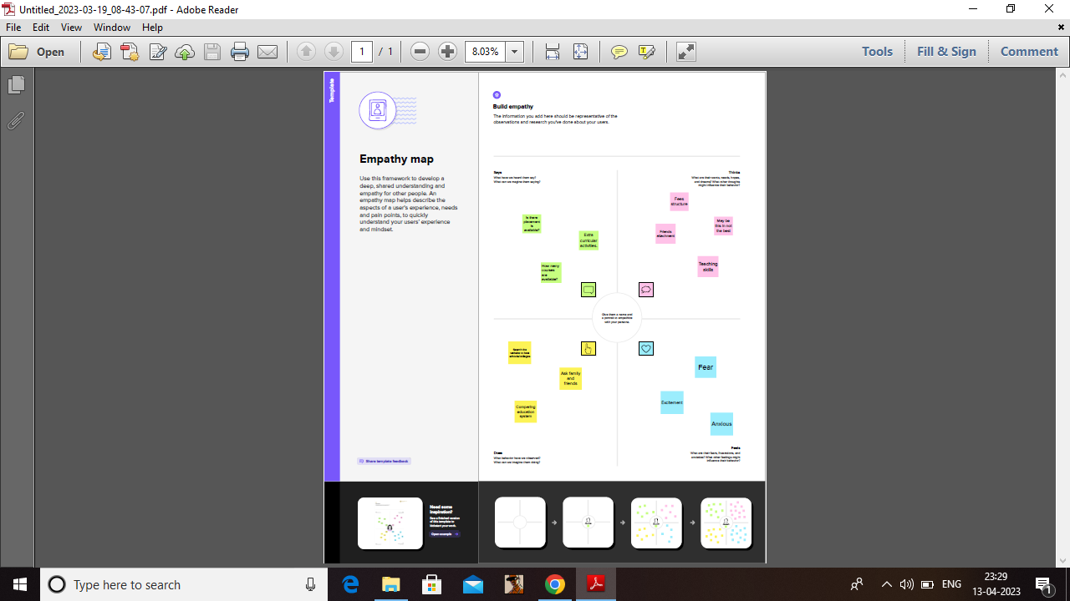

**2.2 IDEA &BRAINSTORMING MAP**

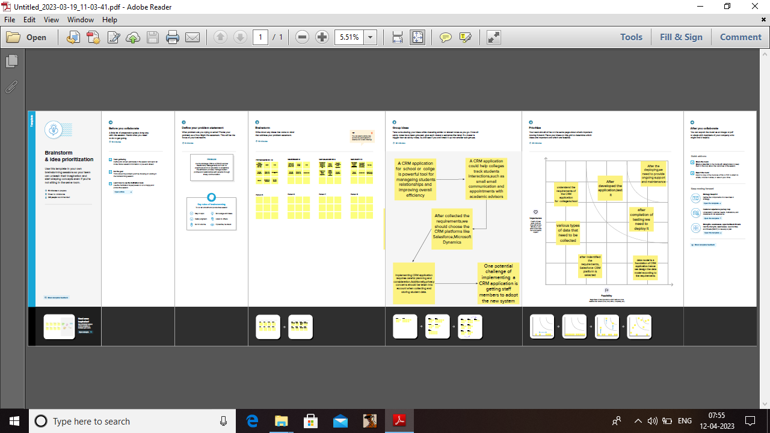

**3. RESULT**

**3.1 DATA MODEL:**

|  |  |
| --- | --- |
| **OBJECT NAME** | **FIELDS IN THE OBJECT** |
| School | |  |  | | --- | --- | | **Field label** | **Data type** | | Address | Text Area | | District | Text Area | | State | Text Area | | School websites | Text Area | |
| Student | |  |  | | --- | --- | | **Field label** | **Data type** | | Phone number | Phone | | School | Master detail relation | | Result | Picklist | | Class | Number | | Marks | Number | |
| Parent | |  |  | | --- | --- | | **Field label** | **Data type** | | Parent Address | Text Area | | Parent Number | Phone | |

**3.2 ACTIVITY & SCREENSHOT**

Milestone-1: Account activated

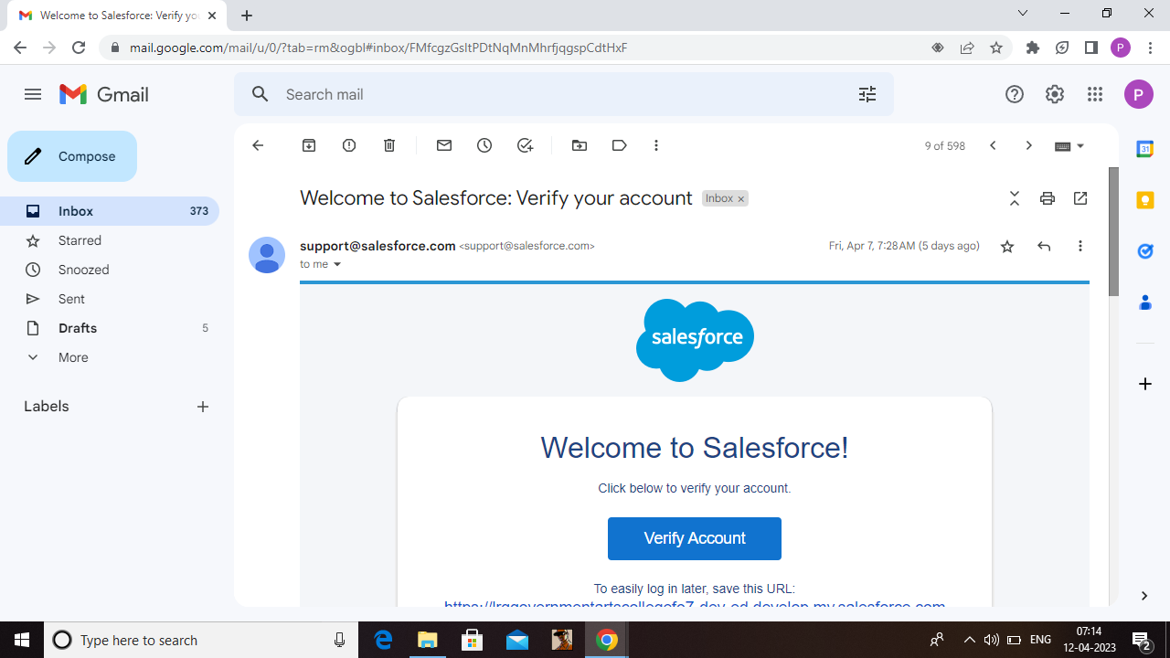

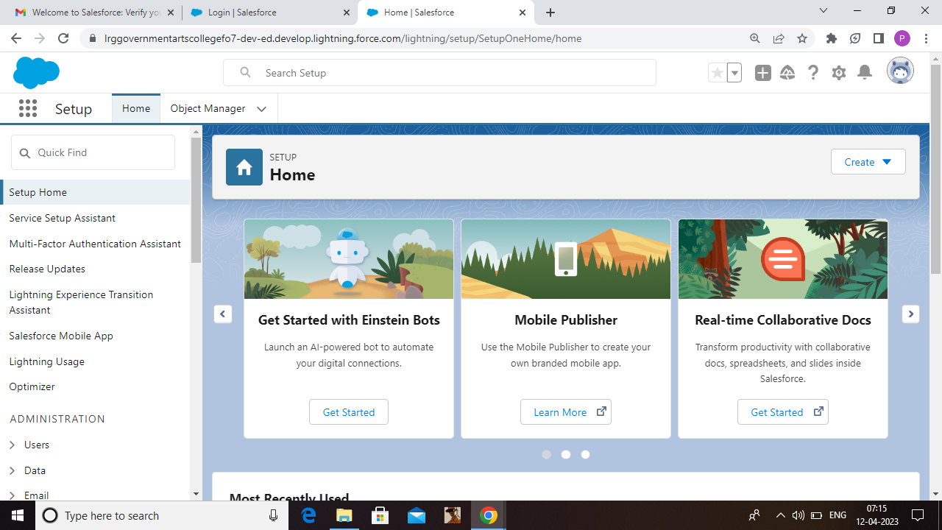

Milestone-2: Object

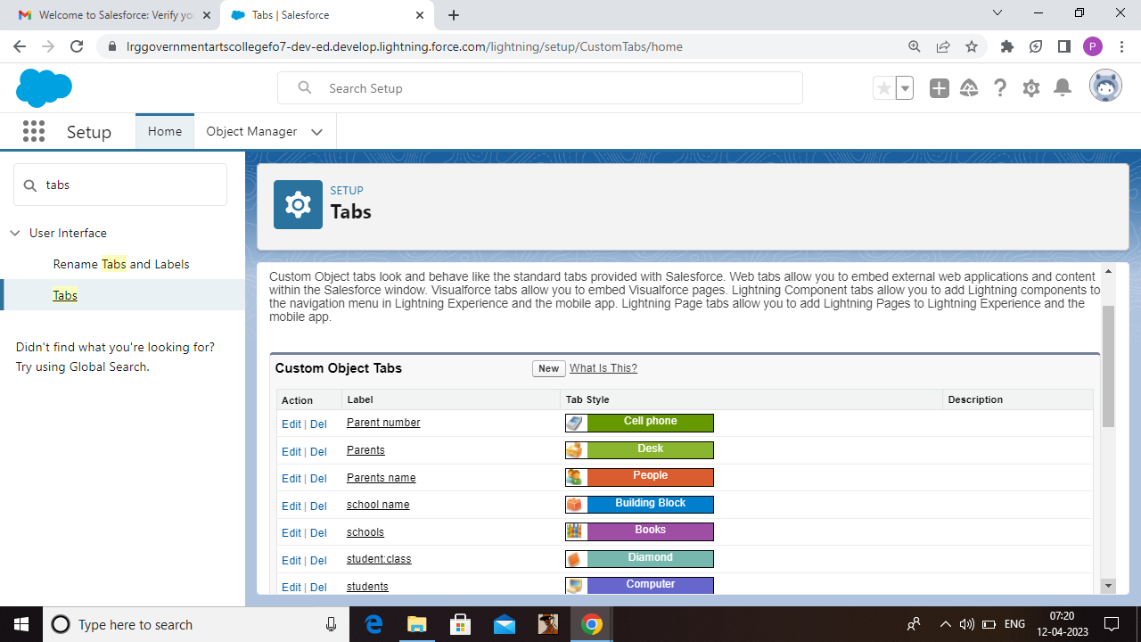

Milestone-3: Lightning App

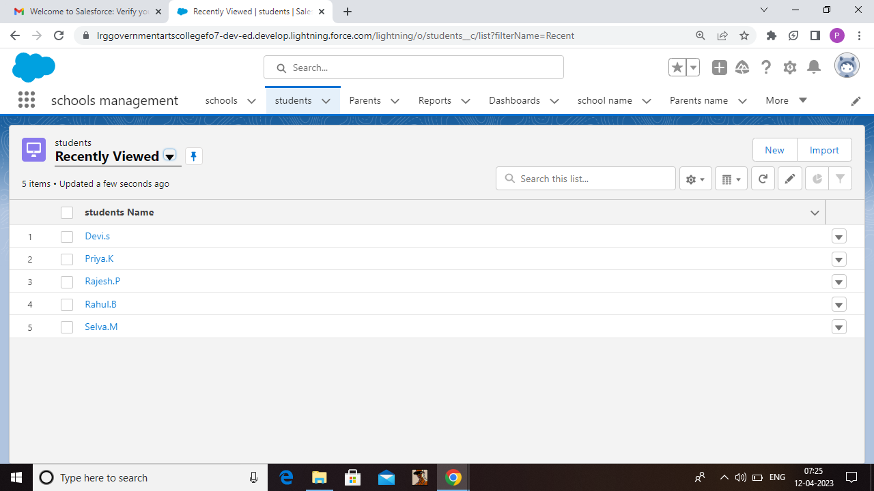

App Name: School management

Milestone-4: Fields and Relationship (fields for school object ,student object, parents object)

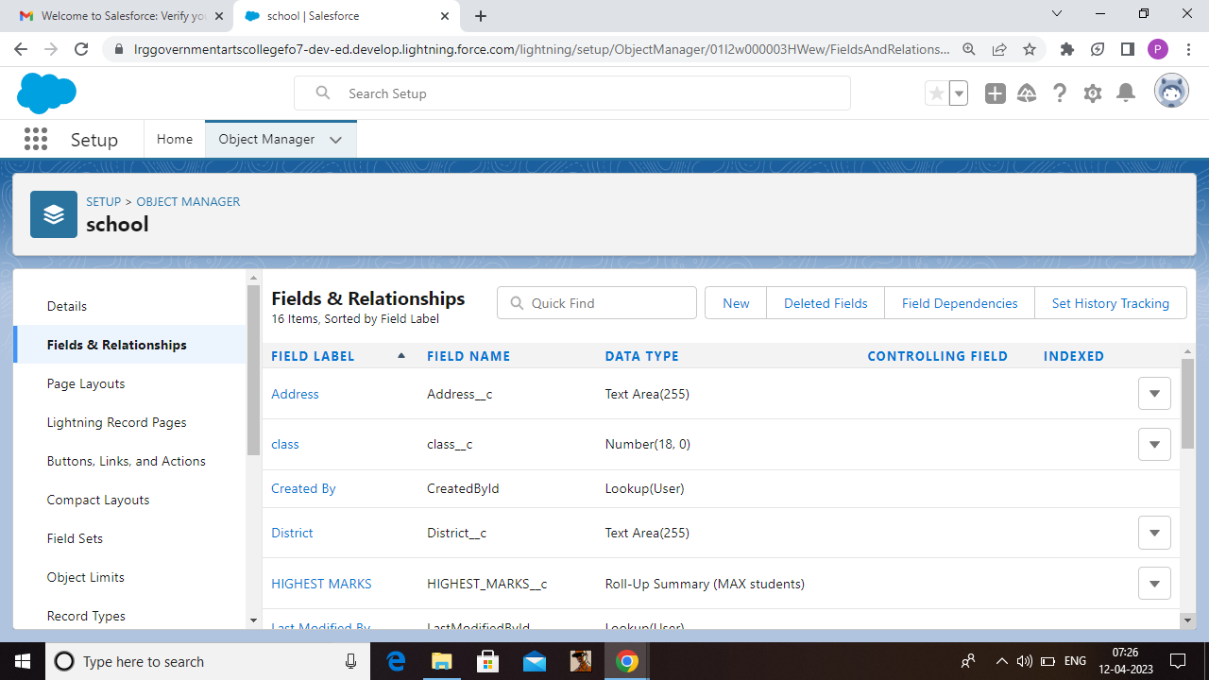

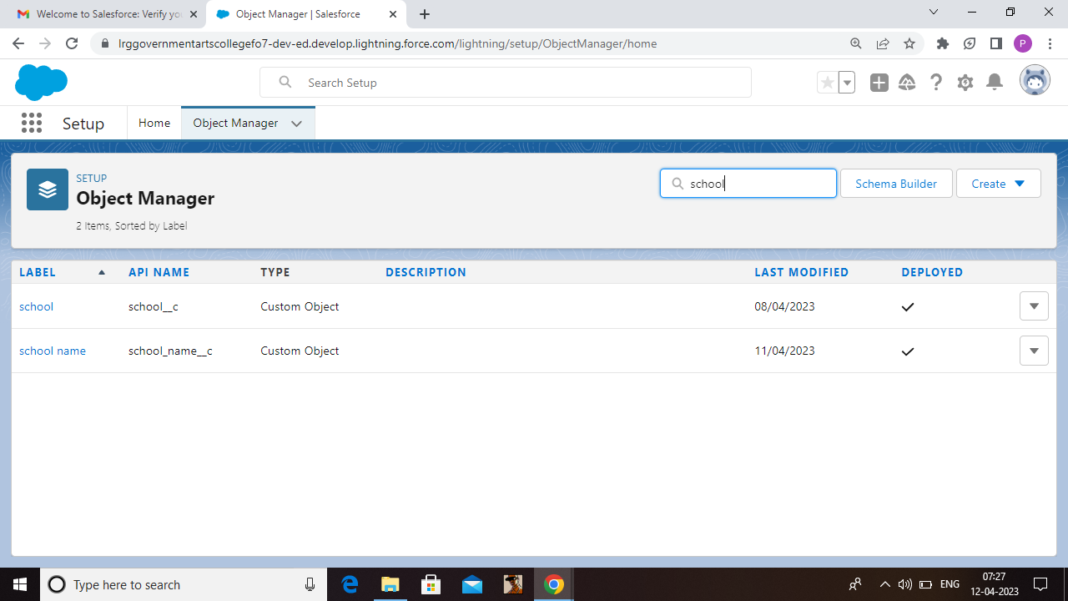

Student object:

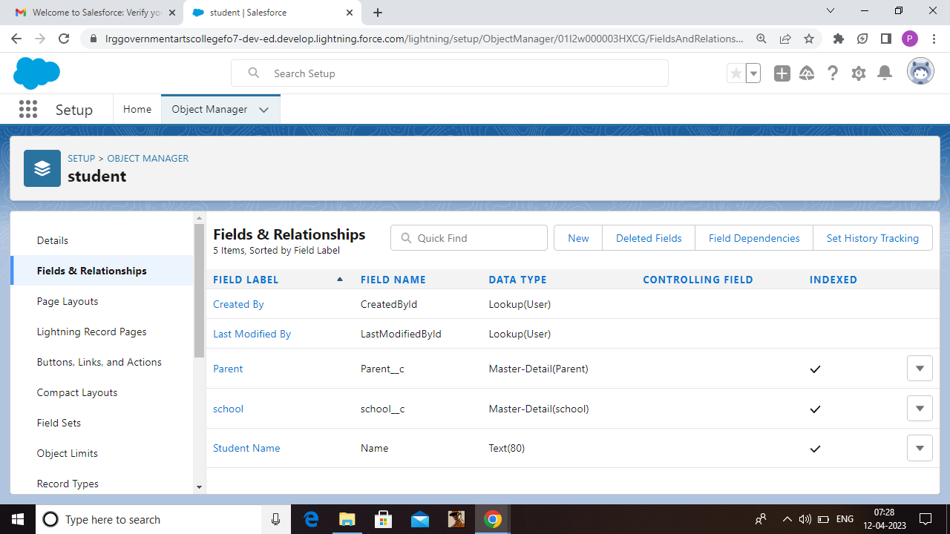

Parent object:

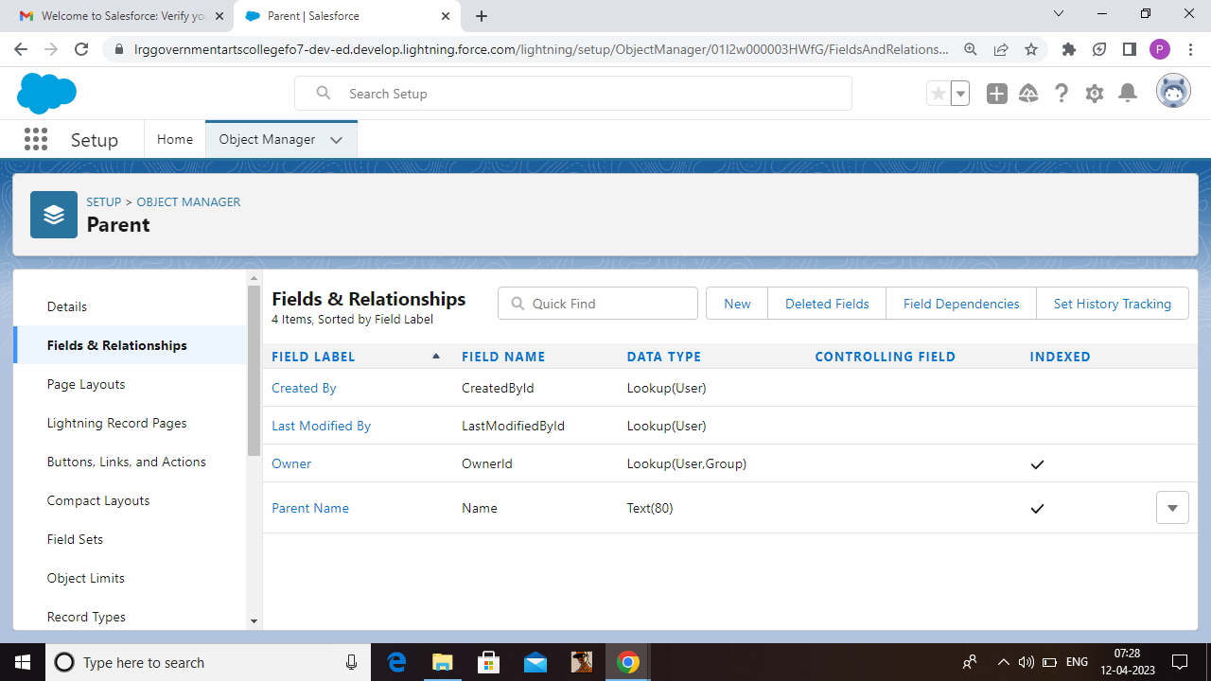

Milestone-5: Profile

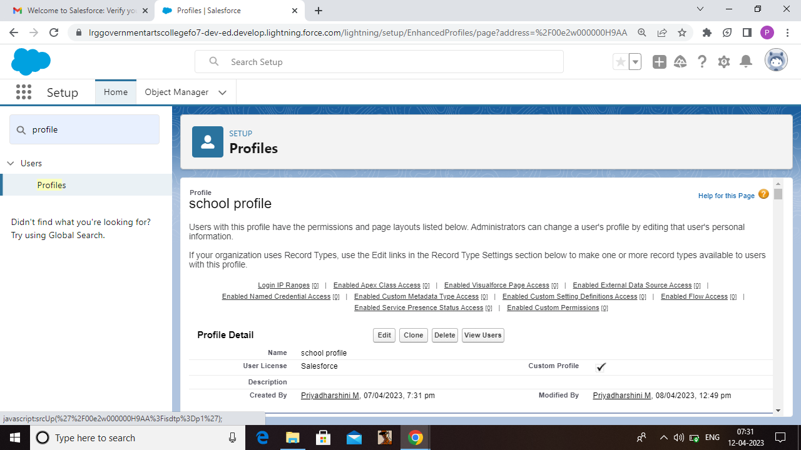

Milestone-6: Users

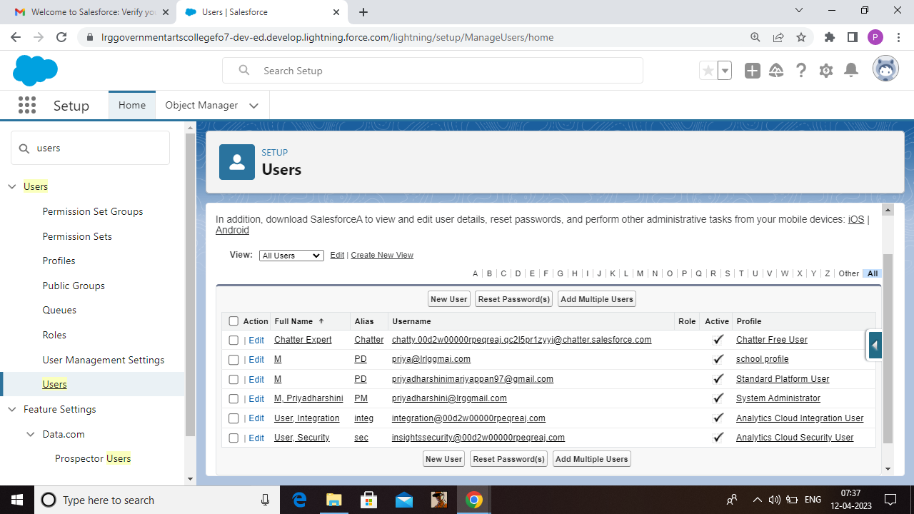

Milestone-7: Permission sets 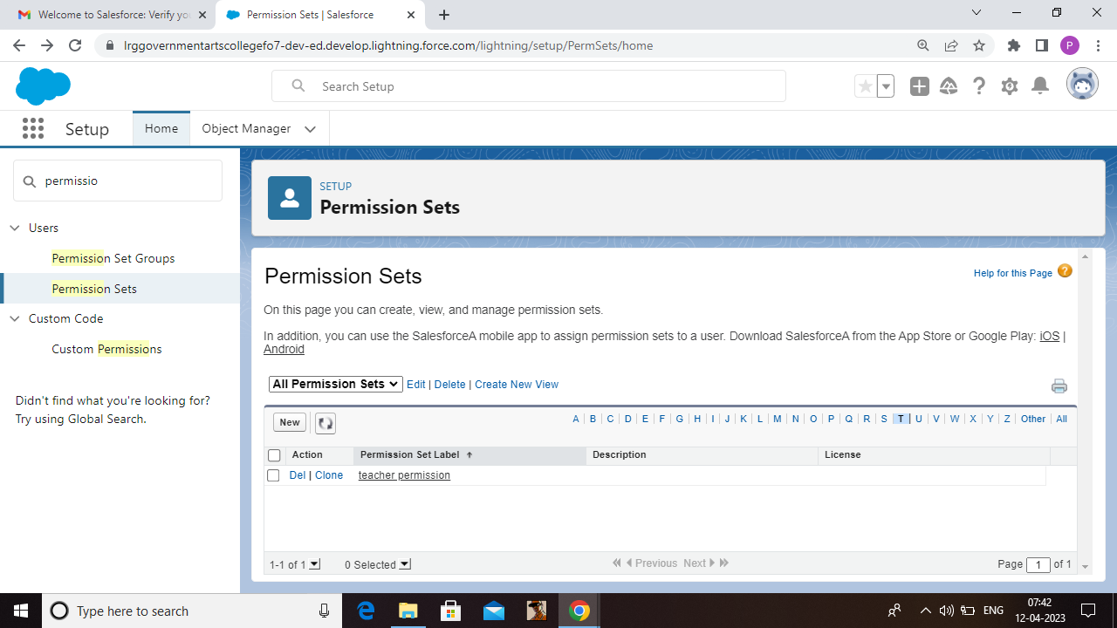

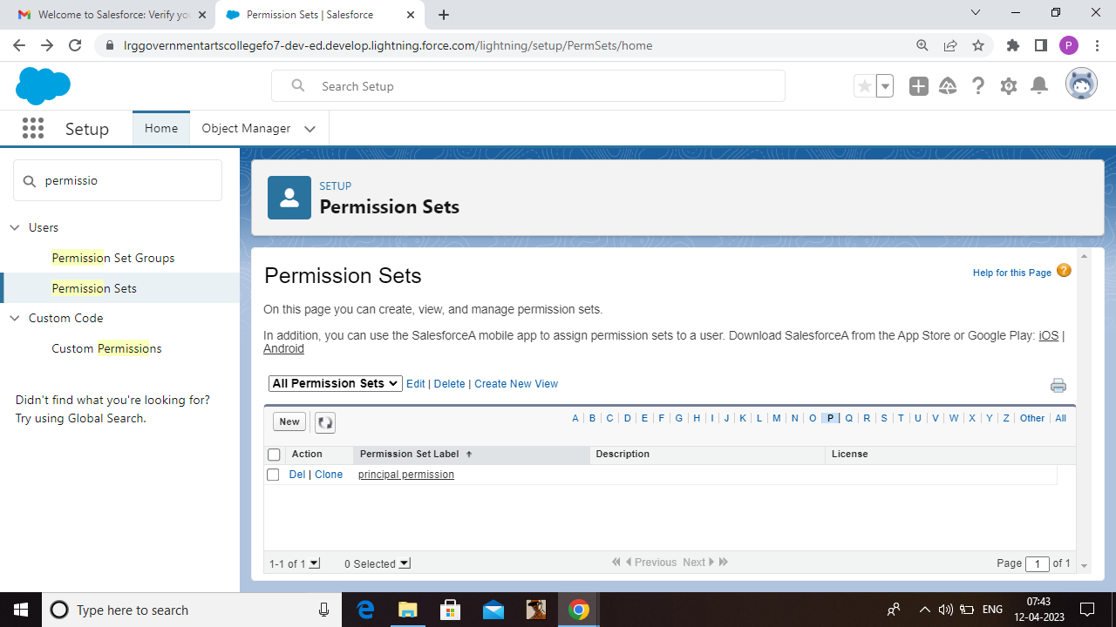

Milestone-8: Reports

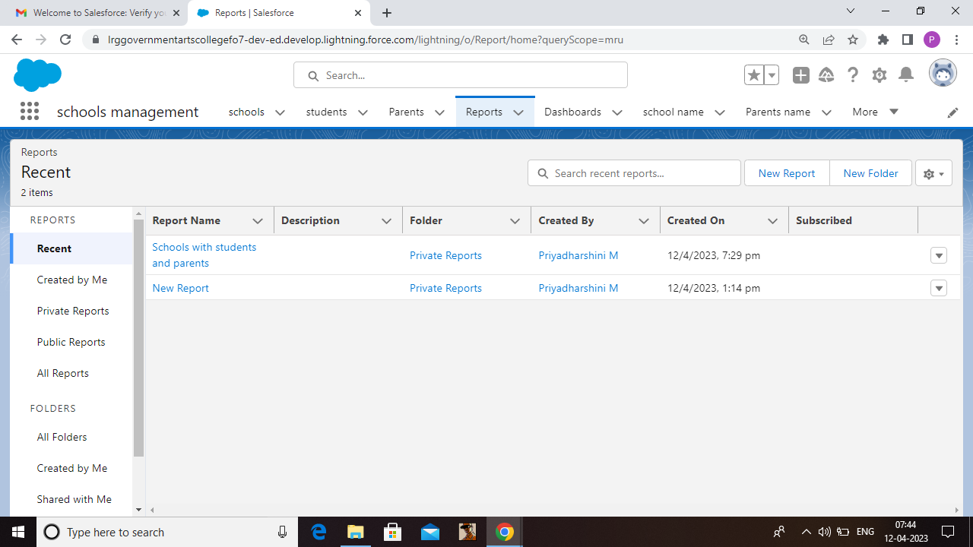

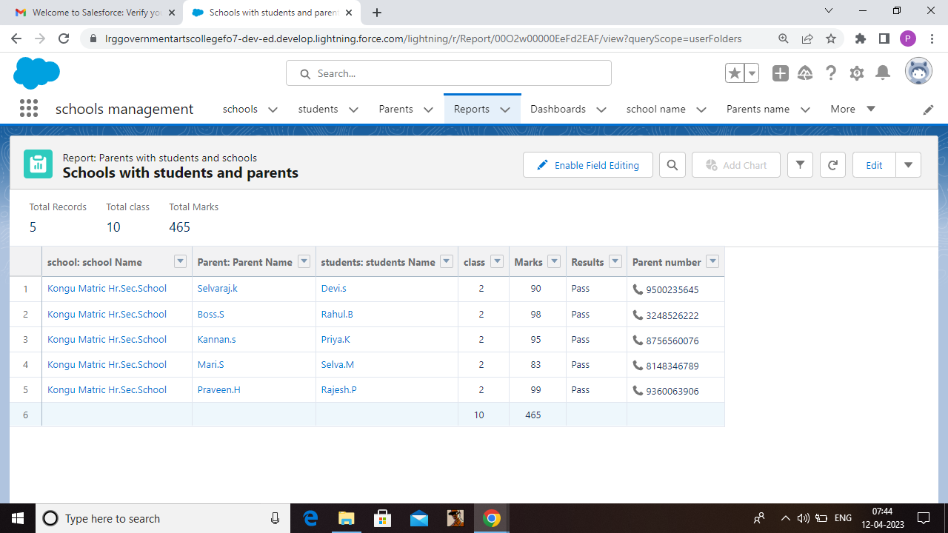

**4 Trailhead Profile Public URL**

**Team leader -**https://trailblazer.me/id/priym53

**Team member 1-**https://trailblazer.me/id/mahem45

**Team member 2-**https://trailblazer.me/id/kanaa11

**Team member 3-**https://trailblazer.me/id/sarus7

**5 ADVANTAGES & DISADVANTAGE**

**ADVANTAGES**

* Trustworthy reporting
* Simplified collaboration
* Improved messaging with automation
* Proactive service
* Simplified student requirement
* Connected experience
* Customized student experience
* Support students

**DISADVANTAGES**

* Expensive . One of the greatest challenges to CRM implementation is cost.
* Lack of leadership.
* Configuration and setup is complex and time consuming.
* Mentor support during project time has very poor.
* Poor communication.

**6 APPLICATIONS**

This salesforce CRM Application for schools/colleges is for the purpose of school/colleges to maintain relationship with parents.

Then it maintain relationship between school management, students , Parents.

**7 CONCLUSION**

Customer relationship management enables a company to align its strategy with the needs of the customer in order to meet those needs and ensure long-term customer loyalty. A CRM system helps you keep your customer contact details up to date , track every interaction they have with your business, and manage their accounts.

**8 FUTURE SCOPES**

Customers will become a company’s best sales reps through superior products and services as well as customer oriented messaging. The future of CRM is more than just the future of customer relationship management software. It is really the future of business.

The right salesforce training props us ahead in a nice area where the scope for career growth and salary is sky-high.